

Semester 2 Examination, 2012

Question/Answer Booklet

MATHEMATICS

3C/3D (Year 12)

Section Two:

Calculator-assumed

Your name: SOLUTIONS

Your teacher: S Ebert T Hosking S Rowden

Time allowed for this section
Reading time before commencing work: ten minutes
Working time for paper: one hundred minutes

Material required/recommended for this section

To be provided by the supervisor
This Question/Answer booklet
Formula sheet (retained from Section One)

To be provided by the candidate
Standard items: pens, pencils, pencil sharpener, eraser, correction/tape fluid, ruler, highlighters

Special items: drawing instruments, templates, notes on two unfolded sheets of A4 paper, and up to three calculators satisfying the conditions set by the Curriculum Council for this course.

Important note to candidates

No other items may be used in this section of the examination. It is your responsibility to ensure that you do not have any unauthorised notes or other items of a non-personal nature in the examination room. If you have any unauthorised material with you, hand it to the supervisor before reading any further.

Structure of this paper

Section | Number of questions available | Number of questions to be answered | Working time (minutes) | Marks available
Section One:  Calculator-free | 7 | 7 | 50 | 50
Section Two:  Calculator-assumed | 13 | 13 | 100 | 100
 |  |  |  | 150

Instructions to candidates

- The rules for the conduct of Western Australian external examinations are detailed in the Year 12 Information Handbook 2012. Sitting this examination implies that you agree to abide by these rules.

- Write your answers in the spaces provided in this Question/Answer Booklet. Spare pages are included at the end of this booklet. They can be used for planning your responses and/or as additional space if required to continue an answer.
- Planning: If you use the spare pages for planning, indicate this clearly at the top of the page.
- Continuing an answer: If you need to use the space to continue an answer, indicate in the original answer space where the answer is continued, i.e. give the page number. Fill in the number of the question(s) that you are continuing to answer at the top of the page.

- Show all your working clearly. Your working should be in sufficient detail to allow your answers to be checked readily and for marks to be awarded for reasoning. Incorrect answers given without supporting reasoning cannot be allocated any marks. For any question or part question worth more than two marks, valid working or justification is required to receive full marks. If you repeat an answer to any question, ensure that you cancel the answer you do not wish to have marked.

- It is recommended that you do not use pencil except in diagrams.

Section Two: Calculator-assumed (100 Marks)

This section has thirteen (13) questions. Answer all questions. Write your answers in the space provided.

Suggested working time for this section is 100 minutes.

Question 8 (5 marks)

A rechargeable battery has a voltage of 9 volts when fully charged. When the battery is used to
run an electronic toy, the voltage V volts, remains at 9 volts for 30 minutes and then the voltage
decreases instantaneously, at a rate modelled by where t is time in minutes.

(a) Find the net change in the battery voltage after the toy has been used for 40 min.
[3]

Specific behaviours
identified t = 10
recognised it was a total change question
correct answer, with negative sign

(b) Find how long the battery can be used to run this toy if a minimum voltage of 8 volts is
required.
Specific behaviours
correct calculation either as above or from determining V(t) and using this to solve the
answer
correct answer (-1/2 if didn’t add on 30 minutes)
[2]
Total time = 5.27 + 30 = 35.27 minutes

Question 9 (6 marks)
A body is moving in a straight line with velocity, m/s, given by , where is the time, in seconds, since the body first passed through a fixed point P.

(a) At what other time(s), if any, does the body again pass through the fixed point P?
[3]

Hence after 4.724 and 9.526 seconds.

Specific behaviours
determines x(t) including acknowldging that c = 0
sets x(t) = 0
solves x(t) = 0, including acknowldeging t = 0 is an answer to the equation, and states 2 other times

(b) Show that the body is stationary twice and find the distance travelled by the body between these two instants.
[3]

Specific behaviours
determines when body is stationary
Appropriate formula/calculation to determine distance
determines distance travelled between these two instances correctly

Question 10 (7 marks)

On the basis of the results obtained from a random sample of 81 bags produced by a mill, the 95% confidence interval for the mean weight of flour in a bag is found to be (514.56g, 520.44g).

(a) Show the value of , the mean weight of the sample is 517.5 g.
[1]

Specific behaviours
correct answer

(b) Find the value of , the standard deviation of the normal population from which the sample is drawn.
[2]

Specific behaviours
appropriate formula/calculation to determine the standard deviation
correct standard deviation

(c) Calculate the 99% confidence interval for the mean weight of flour in a bag.
[2]

Specific behaviours
appropriate formula/calculation to determine the interval
correct interval

(d) Using the sample mean from (a) as the best estimate for the population mean, what is the probability that the sample mean of a larger sample of 225 bags is less than 516 g?
[2]

Specific behaviours
Uses correct parameters
correct probability

Question 11 (7 marks)

Atmospheric pressure, (kPa), decreases approximately exponentially with increasing height (m), above sea level according to the relationship , where is a constant. Atmospheric pressure at sea level is 101.3 kPa, and halves with every 5 800 m increase in height.

(a) Find the value of, rounded to four significant figures.
[2]

Specific behaviours
determines appropriate equation to solve
correct value of k

(b) Calculate the atmospheric pressure at the top of a mountain of height 3 785 m.
[2]

Specific behaviours
Substitutes all information into equation
correct answer

(c) Use the increments formula to find the approximate change in pressure as a climber descends 250 m from the top of a mountain of height 3 785 m.
[3]

(An increase in pressure)

(An increase in pressure)

Specific behaviours
identifies negative change of -250
recognises
correct answer

Question 12 (9 marks)

(a) Even numbers are to be formed using some, or all, of the digits 5, 6, 7, 8 and 9.

(i) How many even numbers can be formed in this way, if repetition of digits is not allowed?
[3]
1-digit:
2-digit:
3-digit: Total = 130 even numbers
4-digit:
5-digit:

Specific behaviours
for working showing number of 1, 2, 3, 4 and 5 digit numbers
correct answer

(ii) What fraction of the numbers in (i) start with a 9? [2]
2-digit:
3-digit:
4-digit:
5-digit:
Fraction

Specific behaviours
working showing number numbers starting with 9
correct answer

(b) The journey time for a driver between two depots is normally distributed with mean of 55 minutes and standard deviation of 4.5 minutes.
(i) If the driver makes four journeys every day, for five days a week, and for 48 weeks each year, how many of these journeys take less than an hour?
[2]

Specific behaviours
correct probability
correctly mulitplies probability by number of journeys

(ii) What is the probability that a journey takes at least an hour, given that it takes less than 65 minutes?
[2]

Specific behaviours
recognises conditional probability
correct answer

Question 13 (12 marks)

(a) A pottery produces souvenir coffee mugs, of which it is known that 5% are defective.

(i) In a box of 24 mugs, what is the probability that there are at least 4 defectives?
[2]

Specific behaviours
correctly identifies the distribution and parameters
correct probability

(ii) In a box of 12 mugs, what is the probability that there are no defectives?
[1]

Specific behaviours
correct probability

(iii) What is the probability that in 10 boxes, each containing 12 mugs, that either two or three of the boxes contain no defectives?
[2]

Specific behaviours
correctly identifies the parameters
correct probability

(iv) The pottery decides to pack n mugs per box for wholesale clients, so that the chance of there being at least one defective mug in a box is no more than 50%. Find the largest value of n.
[2]

Specific behaviours
recognises
solves for n and states correct largest value

Question 13 (continued)

(b) A worker at the pottery took 150 of the defective mugs, filled them with soil and then planted four seeds in each. After 14 days, the number of seeds which germinated in each of the mugs was noted, with these results:

Number of germinating seeds | 0 | 1 | 2 | 3 | 4
Number of mugs | 1 | 9 | 16 | 57 | 67

(i) What is the mean number of seeds germinating per mug?
[1]

Specific behaviours
correct mean

(ii) Show the probability of one seed germinating is 0.8.
[1]
If is the random variable 'number of seeds germinating out of four', then assume that. and so

Specific behaviours
correct justification

(iii) Use an associated binomial distribution to calculate the theoretical frequency distribution for the number of seeds germinating in the 150 mugs and comment on how well your distribution models the observed results above.
[3]

Seeds | 0 | 1 | 2 | 3 | 4
Expected | 0 | 4 | 23 | 62 | 61

The theoretical results are a reasonably close match to the observed results, suggesting that the binomial model is appropriate.

Specific behaviours
uses binomial distribution
gives expect values to whole numbers and ensure + 150
comment on distribution

Question 14 (10 marks)

(a) A spherical snowball is melting at a rate of 18 000 cm³ per hour. At the instant the volume of the snowball is 4 000 cm³, calculate the rate of change of radius of the snowball, in cm per minute.
[4]

Specific behaviours
negative rate of change
correct derivative of volume formula
correct formula for including value of radius
correct anwer in cm³/minute

Question 14 (continued)

(b) (i) The area enclosed by the parabola with equation, the x-axis and the lines
x = 0 and x = 2 rotates about the x-axis. Show that the volume of this solid is
one fifth the volume of the circumscribed cylinder.
[3]
Cylinder
Parabolic
∴ The parabolic section is the circumscribed cylinder
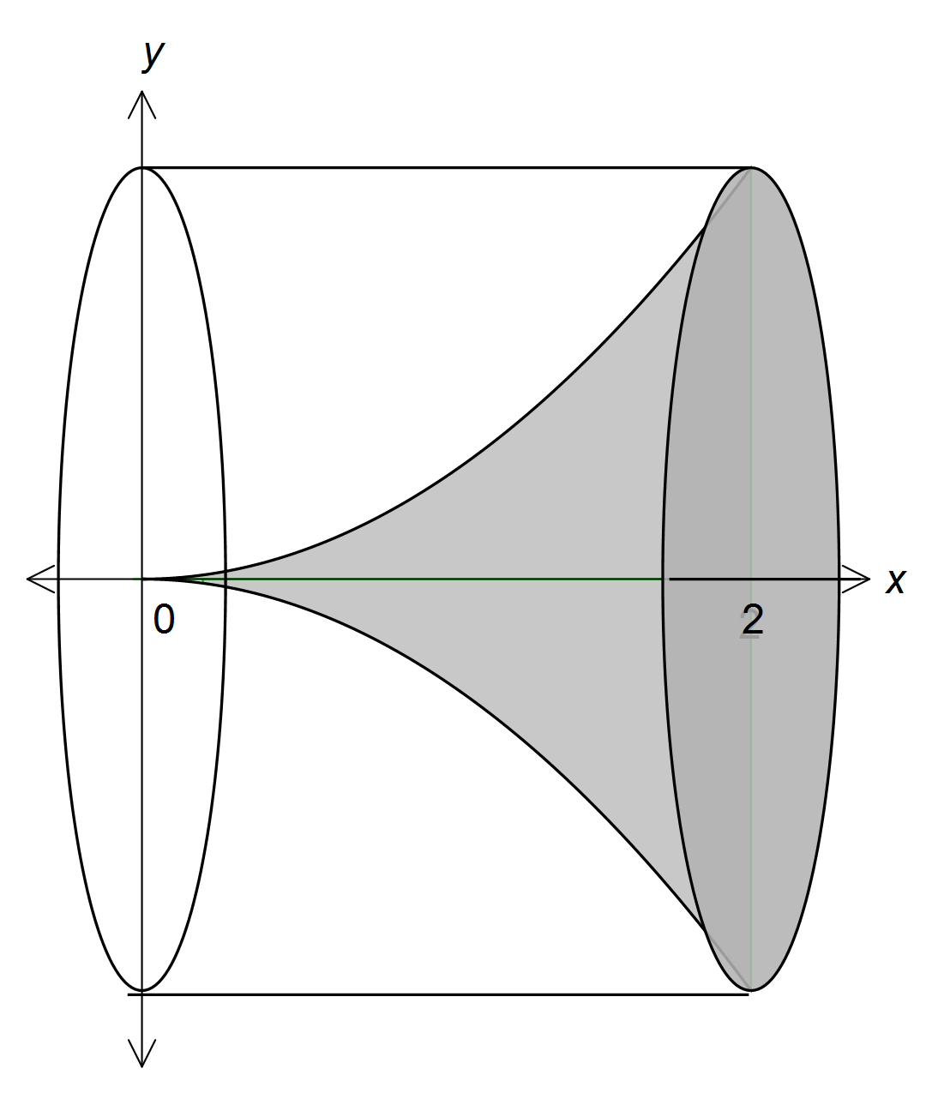

Specific behaviours
volume of cylinder
volume of parabolic function
comparison made and appropriate statement

(ii) Hence, or otherwise, prove that the volume of the solid formed when rotating about the x-axis the area enclosed by the parabola with equation, the
x-axis and the lines x = 0 and x = a, where a is a positive constant, will be one fifth the volume of the circumscribed cylinder.
[3]
Cylinder
Parabolic
∴ The parabolic section is the circumscribed cylinder for 0 ≤ x ≤ a

Specific behaviours
volume of cylinder in terms of a
volume of parabolic function in terms of a
comparison made and appropriate statement

Question 15 (9 marks)

At the end of a technology course, all students sat a practical and a theory examination, with 20% achieving a distinction in the practical examination, 3% of students achieving distinctions in both examinations and 76% achieving no distinction in either examination.

(a) What is the probability that a student chosen at random from the course achieved a distinction in the theory examination?
[4]

Specific behaviours
determines
determines
recognises + =
correct probability

(b) Are the events 'achieving a distinction in the practical examination' and 'achieving a distinction in the theory examination' independent? Explain your answer.
[2]
No. From above it can be seen that .

Specific behaviours
calculation/explanation to justify answer
answer

(c) In a group of 14 students who took the course, three achieved a distinction in the practical examination. If five students are selected at random from this group, what is the probability that at least two of them achieved a distinction in the practical examination?
[3]

Specific behaviours
determines number of combinations for 2 getting a distinction
determines number of combinations for 3 getting a distinction
correct probability

Question 16 (5 marks)

A continuous random variable has the probability distribution function

(a) Calculate

(i) .
[1]

Specific behaviours
correct probability

(ii) .
[2]

Specific behaviours
correct numerator
correct denominator

(b) If , find the value of .
[2]

Specific behaviours
identifies appropriate equation to solve for k
correct value of k

Question 17 (9 marks)

The feasible region of a linear programming problem is shown below.
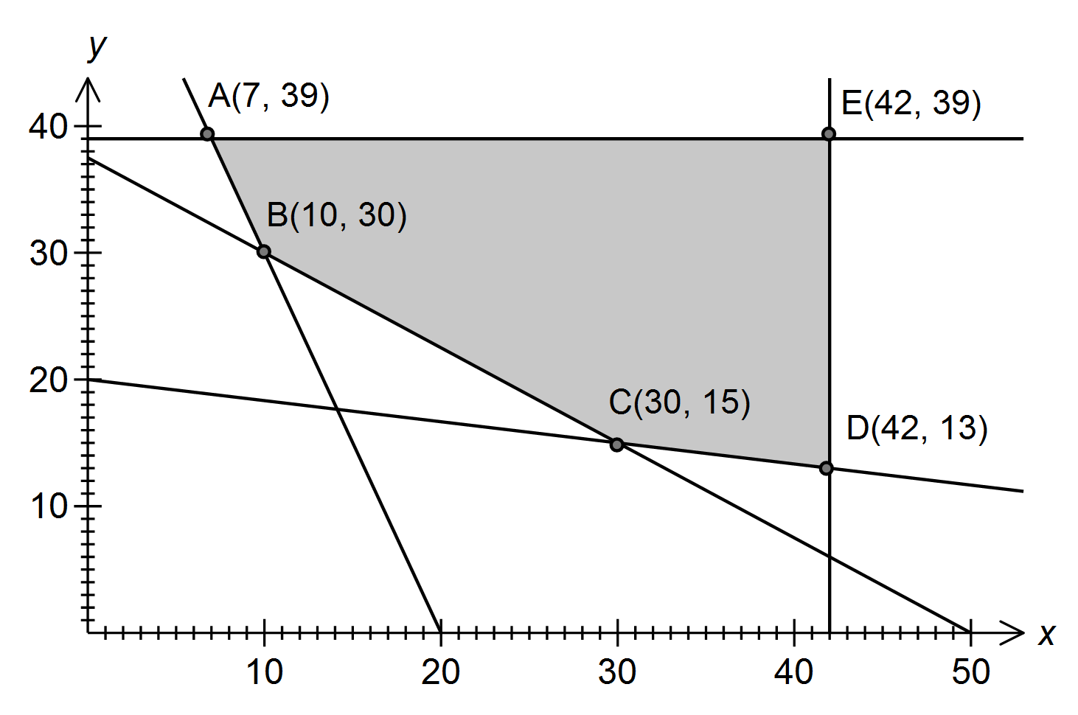
The objective function is .

(a) Determine the inequality satisfied by x and y that corresponds to the edge AB of the feasible region.
[2]

Specific behaviours
correct equation
correct inequality sign

(b) Determine the maximum value of Q in the feasible region.
[1]

Specific behaviours
correct minimum

(c) Determine the minimum value of Q in the feasible region.
[1]

Specific behaviours
correct maximum

Question 17 (continued)

(d) The objective function is changed to .

What is the minimum possible value of the constant a, given that the minimum value of Q still occurs at the same corner point?
[3]
a is 5

Specific behaviours
appropriate working
correct answer

(e) An additional constraint is imposed. How does this additional constraint affect the minimum value of Q in the feasible region?
[2]

No change in since at C(30, 15), where the minimum occurs,
which satisfies the new constraint.

Specific behaviours
comment on affect of additional constraint
justification of comment

Question 18 (10 marks)

Let and , where x and y are integers.

(a) Evaluate A and B whenand.
[1]

Specific behaviours
both values correct

(b) The parity of an object states whether it is even or odd. Complete these tables for the parity of the product and difference of odd and even numbers.

 | odd | even |  |  | odd | even
odd | odd | even |  | odd | even | odd
even | even | EVEN |  | even | ODD | EVEN

[2]
Specific behaviours
correct parity for multiplication
correct parity for subtraction

(c) Examine the parity of A and B for various values of x and y, and hence state a conjecture about the parity of B when A is even. [3]
x | y | A | B
1 | 2 | 8 | 3
1 | 3 | 13 | 4
1 | 4 | 18 | 5
2 | 2 | 15 | 4
2 | 3 | 25 | 5
2 | 4 | 35 | 6
3 | 2 | 20 | 5
3 | 3 | 35 | 6
3 | 4 | 50 | 7

When A is even, B is always odd.
When A is even, B is always odd.

Specific behaviours
various values of x and y (minimum 2)
conjecture

Question 18 (continued)

(d) Prove the conjecture in part (c).
[4]

If is even, then since 3 is odd, must also be odd.

If is odd, then both and must be odd.

Hence is odd.

If is odd, but is odd, then must be even.

Since 5 is odd, then must be even.

Since is odd and is even then , will always be odd.

Specific behaviours
identifies must be odd
explains why x must be odd
explains why y must be even
concluding statement

Question 19 (5 marks)

In the diagram, is a right-angled triangle with and M is the midpoint of PR.
N is the point where the perpendicular to PR at M meets QR.

(a) Prove that .
[2]
(given, M is midpoint)
(common side)
(both right-angles)
(SAS)

Specific behaviours
identifying congruent sides/angles with reasoning
concluding statement with reason for congruency

(b) If PN bisects , show that the ratio of the areas of is .
[3]
and is common side

(AAS)

(from (a)) and so area of , or ratio of areas
is .

Specific behaviours
identifies
recognised all three small triangles are congruent and so is their area
concluding statement regarding ratio
and is common side

(ASA)

(from (a)) and so area of , or ratio of areas
is .

Question 20 (6 marks)

A function is such that .

(a) State the x-coordinate of the minimum of .
[2]

Specific behaviours
determines values of x for
determines value of x for which is a minimum

(b) Justify that has a point of inflection when .
[2]

Specific behaviours
shows and
concluding statement

(c) Find .
[2]

Specific behaviours
identifies as the definite integral from 2 to -1
correct answer

Additional working space

Question number(s):

Additional working space

Question number(s):

Additional working space

Question number(s):

Additional working space

Question number(s):

